INTERREG IVA Programme (2007-2013)
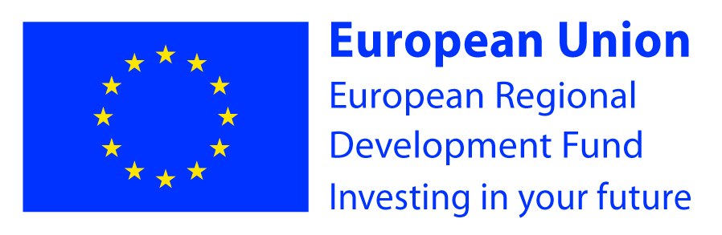

ICBAN and its Partners were successful in securing over €14 million in funding from the EU INTERREG IVA Programme. ICBAN assumed the role of Lead Partner; with responsibility for the management of seven projects, which were supported under the themes of Enterprise, Tourism and Collaboration.

The Cross-Border INTERREG IVA Territorial Co-operation Programme for Northern Ireland, the Border Region of Ireland and Western Scotland was a European Union supported Structural Funds Programme which aimed to promote greater territorial cohesion. The overall theme of the Programme was to strengthen and deepen Programme co-operation, with an emphasis on supporting strategic plans and projects which maximized the impact of funds throughout the eligible area. (INTERREG IVA Operational Programme).

The very essence of the Lead Partner role involved bringing all parties into a common framework and enabling joined up planning and management. As Lead Partner, ICBAN has provided the link between the Projects and the overarching Programme. ICBAN’s role combined administration and technical assistance to enable Partners to meet the requirements of the Programme, with development support to ensure that the impact is maximised and that a legacy is felt across the Central Border Region.

The document ‘ICBAN’s INTERREG IVA Projects’ showcases the seven projects and acknowledges the achievements of all those involved.

